Siapiau

Fideo Cymraeg Cyflym ar YouTube.
Siapiau 2D - 2D Shapes
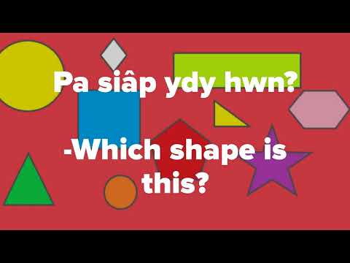

Gemau Siapiau wordwall.
https://wordwall.net/resource/9971176
https://wordwall.net/resource/10393147/siapiau
https://wordwall.net/resource/167038/siapiau
https://wordwall.net/resource/15689043/welsh/siapiau

Caneuon Siapiau.
Cân Siapiau Cyw | Cyw's Shapes Song
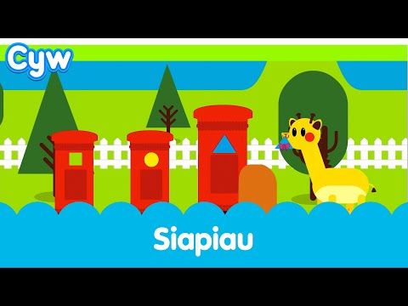

Dewch i Ddawnsio - Siapiau | Dance with Huw | S4C
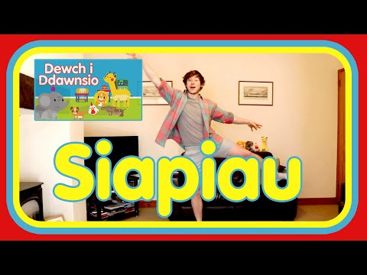

Heriau siapiau.
file:///C:/Users/WieckoA/AppData/Roaming/Microsoft/Windows/Network%20Shortcuts/lliwio-siap-pdf.pdf

file:///C:/Users/WieckoA/AppData/Roaming/Microsoft/Windows/Network%20Shortcuts/helfa-siapiau-shape-hunt.pdf

